MEDIA CONTACT: FOR IMMEDIATE RELEASE
Nina Thompson JULY 4, 2023
619-372-0916
nthompson@sdhumane.org

San Diego Humane Society Waives Reclaim Fees, Extends Adoption Promotion
Lost pets can be picked up with proof of ownership at no cost July 5-16, 2023

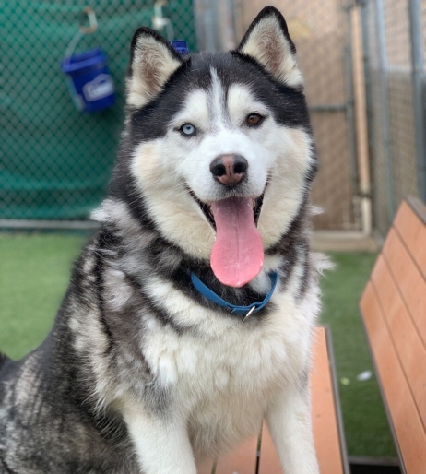
SAN DIEGO — In anticipation of an influx of stray animals after the July Fourth holiday, San Diego Humane Society is waiving reclaim fees for stray pets from July 5-16, 2023, in hopes of returning them home faster. The organization is also extending an adoption promotion to “Empty the Shelters,” with adoption fees 50% off for all adults cats and dogs (7 months and older) through July 30, 2023. The promotion is generously sponsored by BISSELL Pet Foundation.

“We are doing everything we can to get these deserving animals into homes,” said Dr. Gary Weitzman, president and CEO of San Diego Humane Society. “If they are lost, we want them to return to their family where they belong. If they are available for adoption, we want to find their perfect match in our animal loving community.”

Statistics show one out of every three pets will become lost during their lifetime, and only one in 10 will be found. The July Fourth holiday poses particular risks to pets due to the loud noises associated with fireworks and celebrations. According to data from 2022, the nonprofit organization took in 275 stray dogs, cats and other small animals who were lost between July 4 and July 7. Only 16% of those pets were reclaimed by their owners, with dogs accounting for 34%, cats for 14%, and other pets showing a 0% reclamation rate.

If your pet goes missing, access San Diego Humane Society’s Lost2Found program by texting “LOST” to 858-SAN-LOST (858-726-5678). You’ll receive automated text messages with valuable tips and resources to help you in your search! You can also find more information, including how to reclaim your lost pet at San Diego Humane Society, at sdhumane.org/lost.

If you find a stray pet over the holiday, look for identification on the collar and try to connect with the owner. Post photos and a description on social media. Find more resources at sdhumane.org/found.

San Diego Humane Society is open for walk-in adoptions Tuesday – Sunday, from 10 a.m. – 5 p.m. at its campuses in Escondido, El Cajon, Oceanside and San Diego. Visit sdhumane.org/adopt to view animals available for adoption.

B-roll/photos of adult cats and dogs available for adoption for media use available to download here: https://spaces.hightail.com/space/xB2ONfOwyW
Photo credit: San Diego Humane Society

About San Diego Humane Society
San Diego Humane Society’s scope of social responsibility goes beyond adopting animals. We offer programs that strengthen the human-animal bond, prevent cruelty and neglect, provide medical care, educate the community and serve as a safety net for all pet families. Serving San Diego County since 1880, San Diego Humane Society has campuses in El Cajon, Escondido, Oceanside, Ramona and San Diego. For more information, please visit sdhumane.org. Follow the SDHS Media Relations department on Twitter @sdhumane.

###

