MEDIA CONTACT: FOR IMMEDIATE RELEASE
Arika Daniels JUNE 15, 2022
Scatena Daniels Communications
949-338-6672 (cell phone)
arika@scatenadaniels.com

SDHS Reminds Pet Parents to Prepare Ahead of July Fourth Holiday
A few simple steps now could prevent your pet from getting lost!

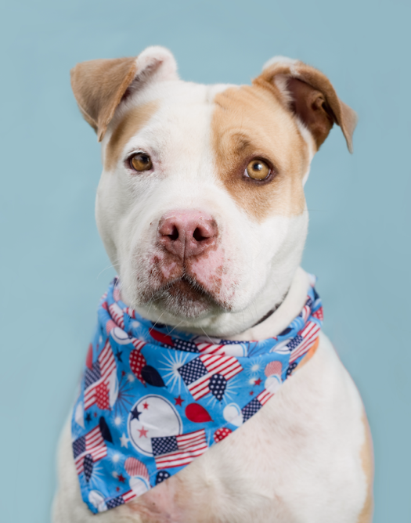
SAN DIEGO — San Diego Humane Society is asking pet parents to plan ahead to keep their furry family members safe this July Fourth holiday. In 2021, the nonprofit organization took in 270 stray dogs, cats and other small animals who became lost between July 4 – 7 and only 28% of those pets were reclaimed by their owners (42% for dogs, 5% for cats, 0% for other small pets).

Sadly, one out of every three pets gets lost during their lifetime, and only one in 10 lost pets are found. The July Fourth holiday can be especially terrifying for pets due to the loud noises associated with fireworks and revelry. Pets spooked by the noise have been known to jump fences out of fear and confusion, resulting in an especially high number of stray animals entering the shelter after July Fourth celebrations. “Pets tend to get very frightened by July Fourth fireworks, whether it’s big firework displays or community members setting off unscheduled fireworks in their local neighborhoods. It’s so important that pet parents have a solid plan to keep their animals calm and safe, since we see a significant increase in stray pets after the holiday,” said San Diego Humane Society Chief Operating Officer Jessica Des Lauriers. “We urge pet families to have that plan in place early, which includes keeping pets home and indoors, in a secure location.”

Pet parents can reduce the risk of their pets getting lost by taking these simple steps:

Ensure your pet is microchipped and the information connected to the chip is up to date. Microchipping is permanent pet identification. The process is safe, simple and designed to quickly identify lost pets and reunite them with their owners. The microchip, which is about the size of a grain of rice (12mm), is injected beneath the surface of the pet's skin between the shoulder blades. The process is similar to a routine shot, takes only a few seconds and your pet will not react any more than she would to a vaccination. No anesthetic is required. San Diego Humane Society is offering $15 microchipping clinics at its campuses in El Cajon, Escondido, Oceanside and San Diego, June 14 – June 30, 2022; Tuesday – Sunday, 10 a.m. to 1 p.m. To learn more, visit sdhumane.org./microchip.

Collars with tags! Make sure your pets have collars with contact information tags and that your dogs are licensed. If you aren’t able to secure tags, simply write your phone number on your dog’s collar with a sharpie. If your pet runs away and you have your phone number on their collar, the person who finds your pet can quickly give you a call and start the reunification process, skipping a trip to the shelter!

Consult a veterinarian for pets with anxiety. If your pet is particularly scared during July Fourth celebrations, medication may help them stay calm. Make an appointment early with your veterinarian to seek out remedies to lower your pet’s stress level if this is a known issue.

Create a home sanctuary. When scared, some animals may become destructive, so be sure to remove anything from reach that can become damaged or may harm your pet if chewed or eaten. Leave your pet in an area of your home where they are safe, comfortable and sheltered from any outside noise and lights.

Make plans early for a pet sitter! If you won’t be home during July Fourth celebrations, consider finding someone to watch your pet. Having company can help them stay calm and ensure they don’t become lost.

All San Diego Humane Society shelters will be closed on Monday, July 4. If you find a stray pet over the holiday, please keep them separate from your own pets, keep them safe overnight and bring them to us on July 5, during normal business hours from 10 a.m. - 6 p.m. If you are unable to care for a lost pet overnight, contact our Humane Law Enforcement dispatch at 619-299-7012 (press 1). If you lose a pet over the holiday, please check our Found Pets page at sdhumane.org/lostandfound on July 5.

B-roll and photos for media use are available to download here: https://bit.ly/3NPyjGE

Suggested Tweet: San Diego Humane Society reminds pet parents to plan ahead to keep their pets safe during the July 4 holiday. Pets spooked by the noise of fireworks have been known to jump fences out of fear. Ensure they're inside, microchipped & have a collar with tags! sdhumane.org/julyfourth

About San Diego Humane Society
San Diego Humane Society’s scope of social responsibility goes beyond adopting animals. We offer programs that strengthen the human-animal bond, prevent cruelty and neglect, provide medical care, educate the community and serve as a safety net for all pet families. Serving San Diego County since 1880, San Diego Humane Society has campuses in El Cajon, Escondido, Oceanside, Ramona and San Diego. For more information, please visit sdhumane.org.

###

