MEDIA CONTACT:
Nina Thompson FOR IMMEDIATE RELEASE
619-372-0916 cell May 3, 2021
nthompson@sdhumane.org

Starved Puppy Abandoned in Crate: SDHS Asks for Public’s Help
Crime Stoppers offers reward for information leading to arrest in felony animal cruelty case.
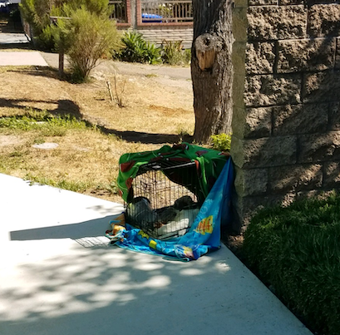
San Diego — San Diego Humane Society’s Humane Law Enforcement is asking for the public’s help in a felony animal cruelty case, involving a severely emaciated puppy who was found dead in a crate on a residential sidewalk in Encanto.

The case was reported to San Diego Humane Society on April 29, 2021. Humane Officers responded to the location on 62nd St., just north of Akins Ave., near the MTS Trolley Station and found the puppy deceased inside the crate. The dog was white, with one brown ear, locked in a kennel that was wrapped with blankets. A witness stated she saw the crate there the night before. Humane Officers transported the puppy to San Diego Humane Society’s San Diego Campus. Upon examination and a necropsy, veterinarians determined the 7-8 month old puppy likely died from starvation.

“This is the second time in less than a month that our Humane Officers are investigating an abandoned dog who starved to death in San Diego County,” said Chief of Humane Law Enforcement Bill Ganley. “While we don’t believe these cases are related, we do want everyone to know: if you need help caring for your pet, please reach out to us before it gets to this point. If anyone has information about this heartbreaking case or has witnessed anything, we ask that you let us know.”

Crime Stoppers is offering a reward of up to $1,000 for information that leads to an arrest in this case. If anyone has information, leads can be reported through an anonymous tip line at 888-580-8477 or visit the Crime Stoppers website at sdcrimestoppers.org for more information on how to send anonymous web and mobile app tips.

Anyone who needs help caring for their pets can contact San Diego Humane Society. The nonprofit organization is an open-admission shelter, meaning it will never turn away an animal in need. For more information, visit sdhumane.org.

If you suspect animal cruelty or neglect in your neighborhood, please report it to San Diego Humane Society by calling 619-299-7012 (press 1 to report animal abuse).

Photos of the dog for media use can be downloaded here: https://bit.ly/3vAZ8oy
(Warning, the photos are difficult to see)

Suggested Tweet: @sdhumane’s Humane Law Enforcement is asking for the public’s help in a felony animal cruelty case, involving a severely emaciated puppy who was found dead in a crate on a sidewalk in Encanto. @sdcrimestoppers is offering up to a $1,000 reward. Call 619-299-7012 with tips.

About San Diego Humane Society
San Diego Humane Society’s scope of social responsibility goes beyond adopting animals. We offer programs that strengthen the human-animal bond, prevent cruelty and neglect, provide medical care, educate the community and serve as a safety net for all pet families. Serving San Diego County since 1880, San Diego Humane Society has campuses in El Cajon, Escondido, Oceanside, Ramona and San Diego. For more information, please visit sdhumane.org.

###

